Mr. Abhinesh Kumar Sahu
Faculty Profile Template
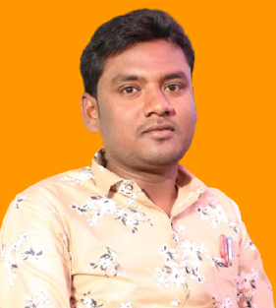
- Basic Information
- Name: Mr. Abhinesh Kumar Sahu
- Designation: Assistant Professor
- Department/School: CSE(Data Science)
- Institution Name: Shri Shankaracharya Institute Of Professional Management & Technology, Raipur
- Email ID:abhinesh.kumarsahu90@ssipmt.com
- Contact Number:7999703611
- Photograph:
- Educational Qualifications
Degree | Specialization | Institution | Year of Completion
UG | BE(CSE) | MATS UNIVERSITY ,RAIPUR | 2012
PG | MTECH(CSE) | KALINGA UNIVERSITY, RAIPUR | 2016
Ph.D.
Others | (if applicable)
- Teaching & Research Experience
- Total Teaching Experience:6+ Years
- Industry Experience: Nil
- Research Experience:2 research paper published in MTech(CSE)
- Courses Taught
- Database Management System
- Operating System
- Computer Network
- Data structure and algorithm
- Webpage Designing
- Mobile application and development
- Ecommerce
- Network Management
- Desktop publishing
- Computer fundamental & application

- Research Interests / Specialization
- Nil
- Publications (Last 5 Years)
- Nil
- Research Guidance
Level | Awarded | Ongoing
Ph.D.
PG | Yes
- Awards & Recognitions
- Nil
- Administrative Roles
- Nil
- Professional Memberships
- Nil
- Web Presence
- Linked in:- https://www.linkedin.com/in/abhinesh-sahu-6a5aa5316/
- Facebook-https://www.facebook.com/abhineshkrsahu
Google scholar -https://scholar.google.com/citations?view_op=list_works&hl=en&hl=en&user=gEDmBo8AAAAJ

