**Faculty Profile Template**

1. **Basic Information**

* **Name**: Saurabh Mishra
* **Designation**: Assistant Professor
* **Department/School**: Computer Science and Engineering
* **Institution Name**: Shri Shankaracharya Institute of Professional Management and Technology Raipur
* **Email ID**: saurabhmishra@ssipmt.com
* **Contact Number**: 8770673073
* **Photograph**:

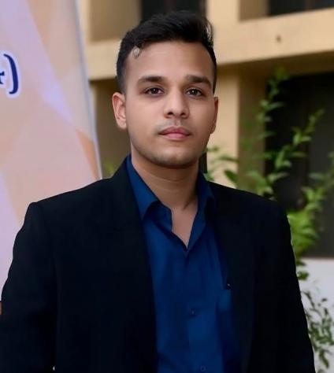

1. **Educational Qualifications**

|  |  |  |  |
| --- | --- | --- | --- |
| **Degree** | **Specialization** | **Institution** | **Year of Completion** |
| UG | CSE | Sant guru gahira university | 2019 |
| PG | CSIS | Manipal University | 2023 |
| Ph.D. | CSE | Mats University | Pursuing |
| Others | *(if applicable)* |  |  |

1. **Teaching & Research Experience**

* **Total Teaching Experience**: 2 Years
* **Industry Experience**: *(if any)*
* **Research Experience**:

1. **Courses Taught**

* Programming for problem solving
* Principal of Programming languages
* Computer System Architecture
* Operating System

1. **Research Interests / Specialization**

* Machine Learning
* Artificial Intelligence

1. **Publications (Last 5 Years)**

* Journals (APA/IEEE format)
* Conference Proceedings
* Book Chapters / Books Authored

1. **Research Guidance**

|  |  |  |
| --- | --- | --- |
| **Level** | **Awarded** | **Ongoing** |
| Ph.D. | NA | NA |
| PG | NA | NA |

1. **Awards & Recognitions**

* Institutional / National / International

1. **Administrative Roles**

* Positions held (e.g., HoD, IQAC Coordinator, NAAC/NBA Committee Member)

1. **Professional Memberships**

* e.g., ISTE, IEEE, INFLIBNET, etc.

1. **Web Presence**

* Personal academic webpage / Google Scholar / ResearchGate / ORCID